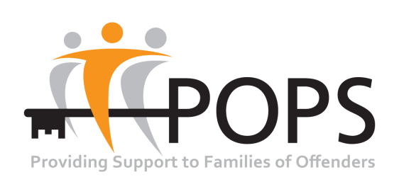
Diversity Monitoring Form

The following information will be retained by the POPS Human Resources Department for monitoring purposes only.
POPS is registered with the Information Commissioners Office (ICO) to ensure that any processing of personal data for which they are responsible complies with the Act. The POPS ICO Registration Number is: Z8725561

Gender Male Female
Are you married or in a civil partnership Yes No
Age 16-24 25-29 30-34 35-39 40-44 45-49 50-54 55-59 60-64 65+
Prefer not to say
Do you consider yourself to be disabled?

Yes No Prefer not to say

What is your sexual orientation?

Heterosexual/straight Gay woman/lesbian
Gay man Bisexual Transgender
Other Prefer not to say

What is your religion or belief?

No religion Buddhist Christian
Hindu Jewish Muslim
Sikh Any other religion Prefer not to say

What is your ethnicity?
Ethnic origin categories are not about nationality, place of birth or citizenship. They are about the group to which you as an individual perceive you belong. Please indicate your ethnic origin by ticking the appropriate box
White
English Welsh Scottish Northern Irish
Irish Irish Traveller
Other White background

Mixed/multiple ethnic groups
White and Black Caribbean White and Black African
White and Asian Any other mixed background

Asian/Asian British
Indian Pakistan
Bangladeshi Chinese Any other Asian background

Black/ African/ Caribbean/ Black British
African Caribbean
Any other Black/African/Caribbean background

Other ethnic group
Arab Any other ethnic group Prefer not to say

